Digital simulation using ORCAD

English version.

If any faults or mistakes are found, please let me know. Or if any suggestions for new versions, I’d like a sketch of your idea.

Rev. 13/9-05

/Valle

-------------------------------------------------------------------------------------------------------

ORCAD is brilliant when simulating analogue circuits. But also digital circuits can be examined. Gates has a small propagation delay, which in some situations can cause problems. Fx. HAZARD.

ORCAD can handle and show these problems !

Unfortunately only TTL circuits comes with this free version of ORCAD. TTL gates are very low impedant, witch have to be considered.

In the following, some examples are listed. !

Oscillator

Build up the following circuit. The resistor should not be too big !

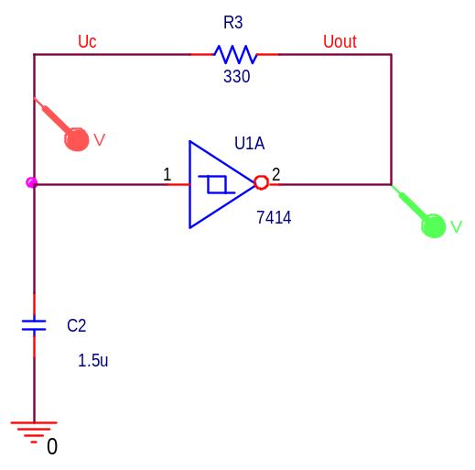
The graph goes is like this:

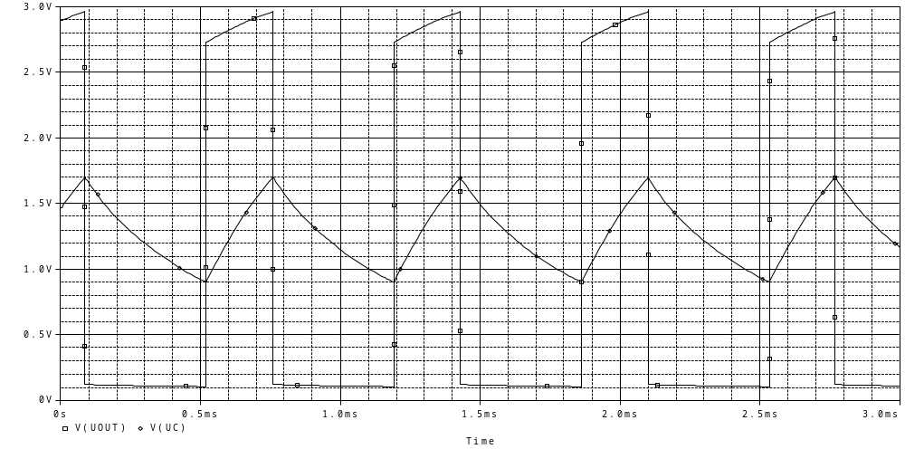

TTL-gates are used. That means, that the voltage by default is 5 Volt. The output of the gates are connected to analog components, so the result will be shown as analog signals.

Analog and digital components:

If a pure digital component are put into the circuit, as in the next example, the output screen PROBE will be split up into two parts. One for the pure digital signals, and one for the analogue signals:

Example 2:

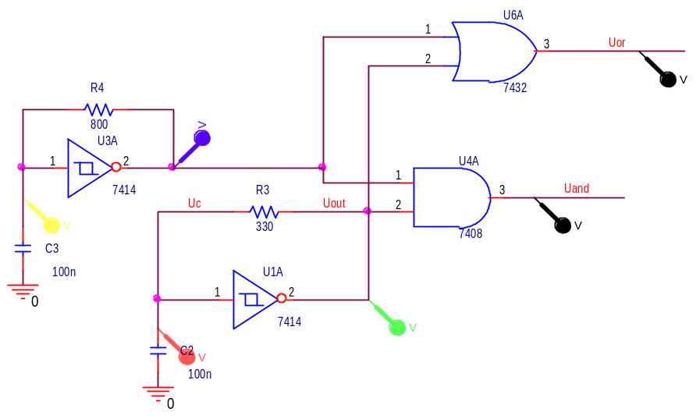

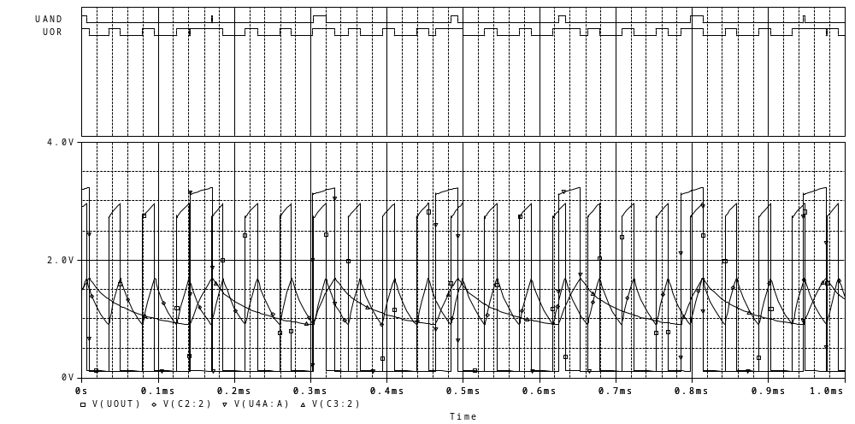

Signal generators, / Clocks

PSPICE has several signal generators that can be used as input for simulating circuits. The simplest one is the DigClock found in PSPICE/Source. It produces a square wave signal, which by default is 1 mega Hertz.

Example:
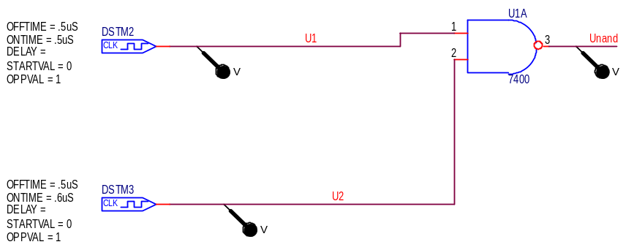

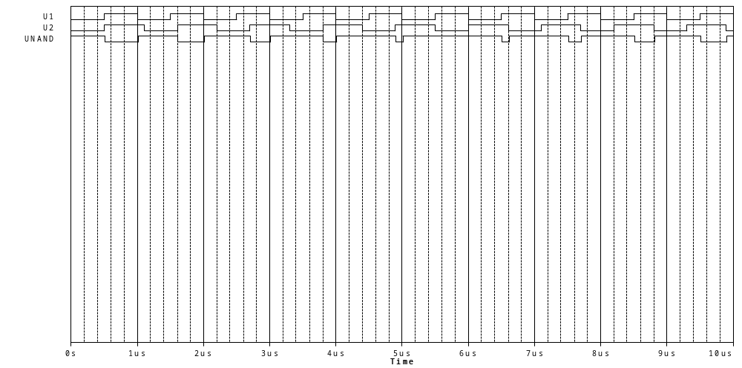

In the circuit, the Digclock gets the name ”DSTM1”. (Digital STiMuli )

The frequency by default is 1 MHz, 50 % duty cycle. The values can be changed by clicking them.

The signal definitions are:

OFFTIME = ( Time for the signal being low ) 0.5 uS
ONTIME = ( Time for the signal being high ) 0.5 uS
DELAY = 0 ( Time before the first shift ) (default)
STARTVALUE = 0 ( The start value is 0 ) (default)
OPPVAL = 1 ( The opposite value of the start value ) (default)

Example:

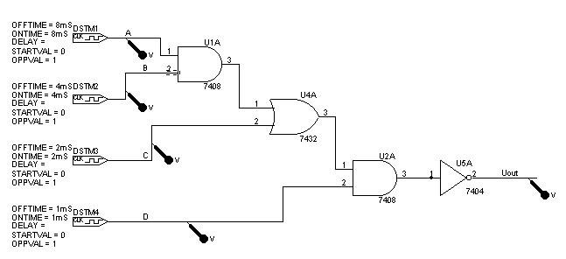

4 DigStim generators have been used. They have been set to 8, 4, 2 and 1 ms, and will then in 16 ms have been trough all 16 combinations.

The wires have got the names A to D. Voltage markers has been applied where the signals is to be examined.

The simulating time is 18 mS, and the result from PROBE is as the following:

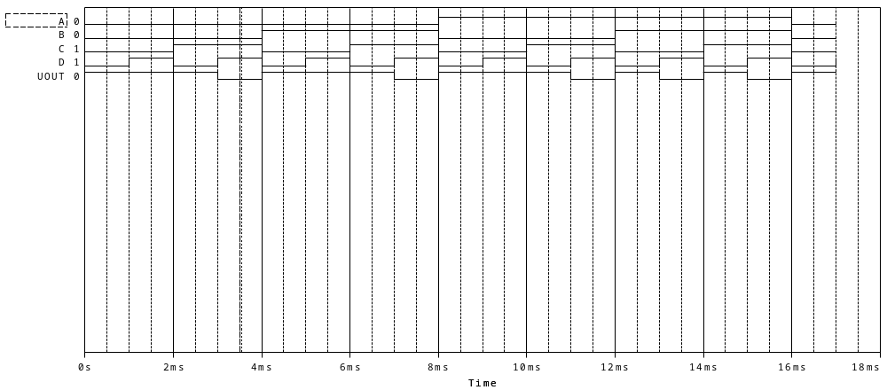

To the left in the graph, the Node names are displayed, and the values from the cursor, when used.

JK-FF

In the next example, a JK-FF is examined.

The circuit is as following:
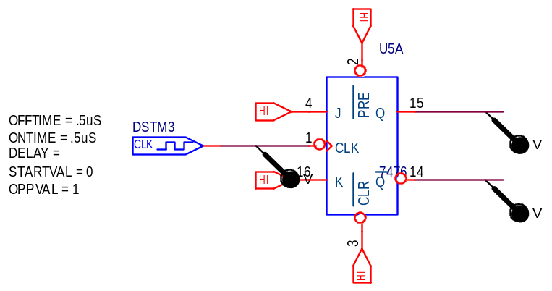

When simulating components with FF’s, it’s important to define the start-value for the FF’s.  Choose “Time Domain / Transient analysis.  In Simulating settings / Options choose Gate Level, and Initialize all Flip Flops to 0.  Otherwise the FF’s can have any 0 or 1 start position ! | 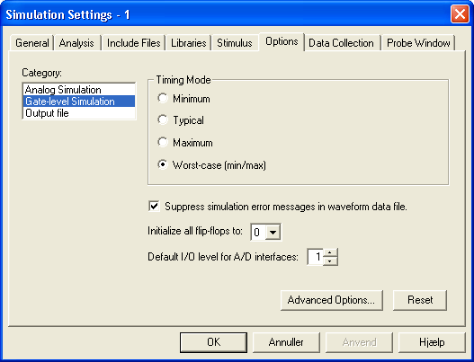

Hi or Lo signals are applied. They can be found from /source by clicking the ”Place / Power” button on the right hand side.

They have to be applied to define the logically state for fx reset etc.

Now the graph:
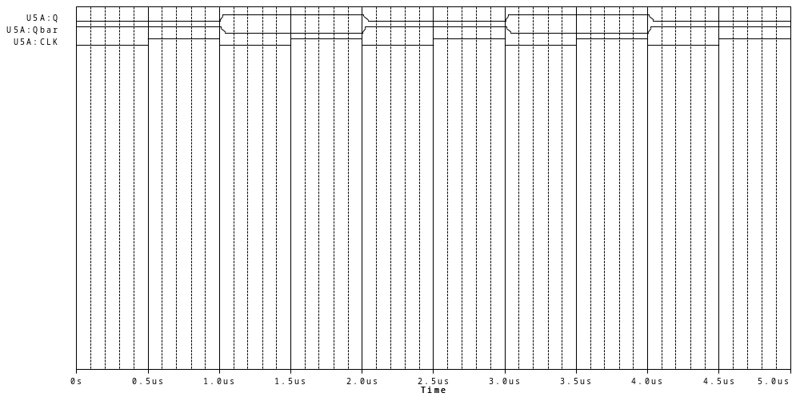
STIM1

If only a short pulse is wanted, the following can be used.

Use the source STIM1. It gives a one-line signal, which has to be specified by some Commands.  Double click the generator to bring up the spread sheet. | 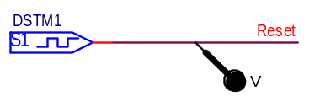

Command0 is default =0.

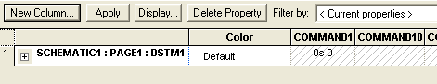 | 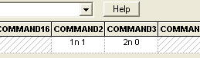

Scroll to Command 1. Type in the time it has to go high. And in Command2 type in when it has to go low again.

The graph looks as:

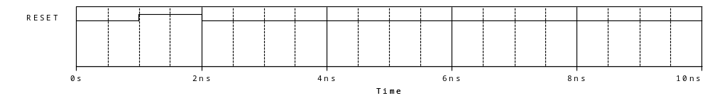

Counter:

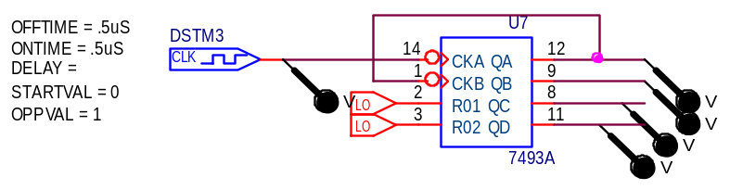

Also here the flip flops should be set to 0 as start value in the Simulation settings / options dialog box. ???

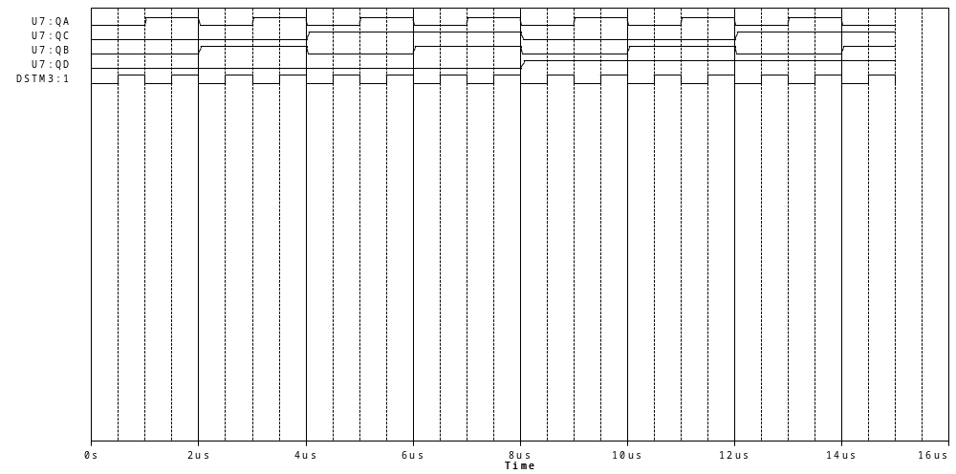

Propagation Delay

In the next example propagation delay is examined.

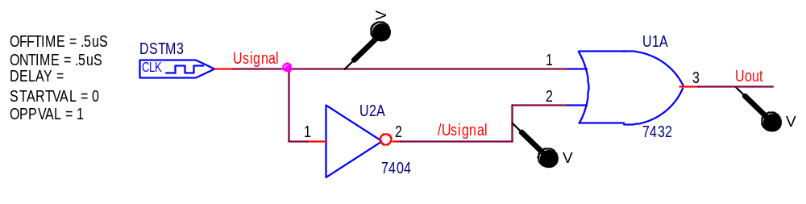
Uout ought to be high all the time, but because of the propagation delay in the inverter HAZARD appears on the Uout signal.

The simulating profile option has been set to worst case: | 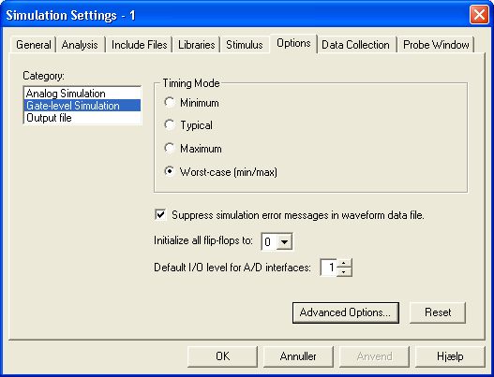

The graph:

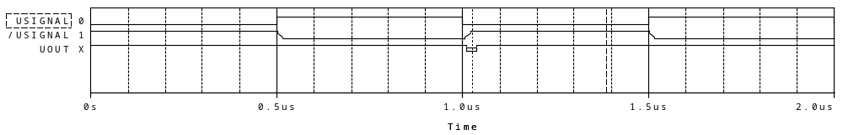

When zoomed in, it’s found, that the output is high, but can be unknown for a period shortly after the clock signal changes from 1 to 0

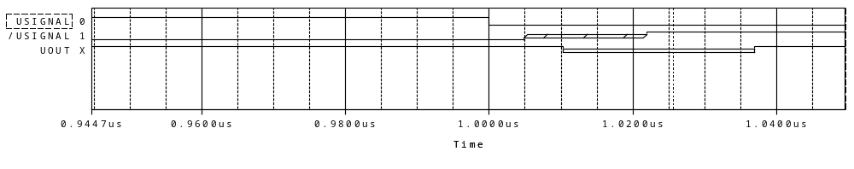
On the left hand side, the state for the signals can be found, when the cursor is “on”. The value changes as the cursor is moved forward and backwards. The signs are explained here:

0 ”Low”
1 ”High”
R “Rising”,
F “Falling”,
X “X for Unknown”
Z “Z for High Impedance”.

